一、

#include<iostream>

using namespace std;

struct student

{ char name[20];

unsigned int id;

double score;

void input()

{ cout<<"name?";

cin>>name;

cout<<"id?";

cin>>id;

cout<<"score?";

cin>>score;

}

void output()

{ cout<<"name:"<<name<<"\tid:"<<id<<"\tscore:"<<score<<endl;}

};

int main()

{ student s;

s.input();

s.output();

}

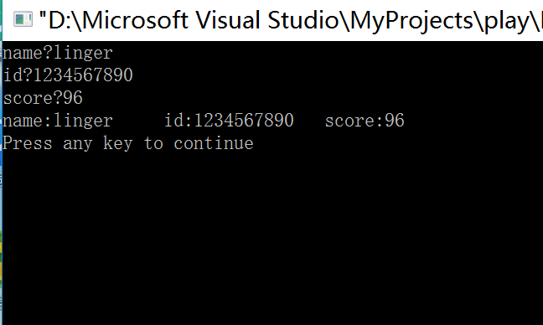

二、

#include<iostream>

using namespace std;

struct Book

{ public:

void setbook(char \*,double,int);

void display();

void borrow();

void restore();

private:

char bookname[40];

double price;

int number;

};

void Book::display()

{ cout<<"书名:"<<bookname;

cout<<"现存数量为:"<<number;

cout<<"价格为一本:"<<price<<"元";

}

void Book::setbook(char \*name,double pri,int num)

{ strcpy(bookname,name);

price=pri;

number=num;

}

void Book::borrow()

{ if(number==0)

cout<<"此书存量为零！";

else

number-=1;

cout<<"借书成功！现存"<<number<<"本";

}

void Book::restore()

{ number+=1;

cout<<"还书成功！现存"<<number<<"本";

}

int main()

{ char m,k;

Book A;

A.setbook("《蓝色的兔耳朵草》",40.5,6);

cout<<"藏书情况："<<endl;

A.display();

k='t';

while( k=='t')

{

cout<<"请输入要进行的操作：a(借书)or b(还书):"<<endl;

cin>>m;

if(m=='a')

{ A.borrow();}

if(m=='b')

{ A.restore();}

cout<<"继续(t)？or退出(f)？"<<endl;

cin>>k;

A.display();

}

}

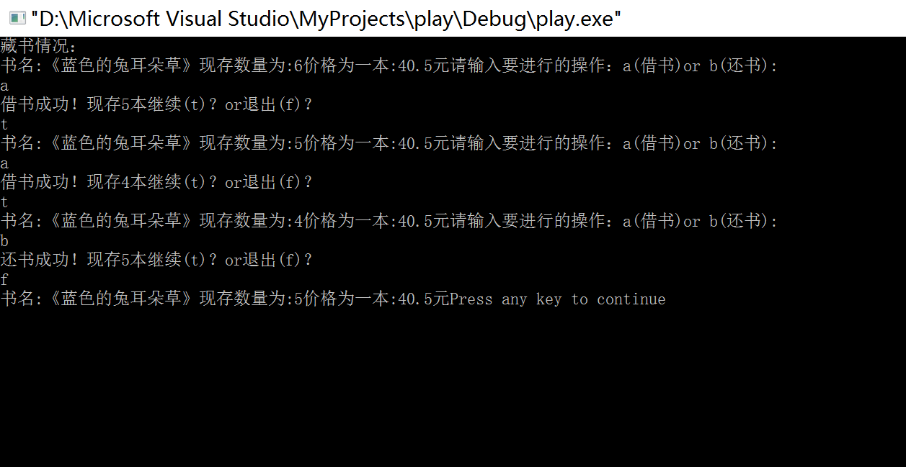

三、

#include<iostream>

using namespace std;

struct student

{ public:

void scoretotalcount(double,int);

static double sum();

static double average();

private:

double score;

static double total;

static int count ;

};

double student::total=0;

int student::count=0;

void student::scoretotalcount(double s,int num)

{ score=s;

total+=s;

count=num;

}

double student::sum()

{

return total;

}

double student::average()

{

return total/count;

}

int main()

{ double s;

int num;

student A;

cout<<"请输入学生人数:"<<endl;

cin>>num;

for(int i=1;i<=num;i++)

{cout<<"请输入第"<<i<<"个学生成绩";

cin>>s;

A.scoretotalcount(s,num);

}

cout<<"全班同学的总分:"<<student::sum()<<endl;

cout<<"全班同学的平均分为："<<student::average()<<endl;

}

